**Tugas Kelompok Matrix**

Anggota :- Yusuf Supriadi 17180068

- Rinandi 17180017

- Ahmad Lukman N 17180012

- Sarifudin Hanafi 17180051

- Fawwas Fadhilah 17180048

1. Penjumlahan dua buah matrix

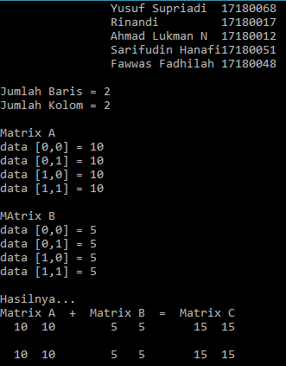

**Coding :**

#include <iostream.h>

#include <conio.h>

#include <iomanip.h>

int i,j, baris, kolom, m1[2][2], m2[2][2], hasil[2][2];

main()

{

clrscr();

cout<<"\t\tYusuf Supriadi\t17180068\n";

cout<<"\t\tRinandi\t\t17180017\n";

cout<<"\t\tAhmad Lukman N\t17180012\n";

cout<<"\t\tSarifudin Hanafi17180051\n";

cout<<"\t\tFawwas Fadhilah\t17180048\n\n";

do

{

cout<<"Jumlah Baris = ";cin>>baris;

cout<<"Jumlah Kolom = ";cin>>kolom;

}

while((baris>2)||(kolom>2));

cout<<"\nMatrix A\n";

for(i=0;i<baris;i++)

for(j=0;j<kolom;j++)

{

cout<<"data ["<<i<<","<<j<<"] = ";

cin>>m1[i][j];

}

cout<<"\nMAtrix B\n";

for(i=0;i<baris;i++)

for(j=0;j<kolom;j++)

{

cout <<"data [" << i << "," << j << "] = ";

cin>>m2[i][j];

}

for(i=0; i<baris;i++)

for(j=0; j<kolom; j++)

hasil[i][j] = m1[i][j] + m2[i][j];

cout << "\nHasilnya...\n";

cout << "Matrix A + Matrix B = Matrix C";

for(i=0; i< baris; i++)

{

cout<<'\n';

for(j=0; j<kolom; j++)

cout << setw(4) << m1[i][j];

cout << " ";

for(j=0; j<kolom; j++)

cout << setw(4) << m2[i][j];

cout << " ";

for(j=0; j<kolom; j++)

cout << setw(4) << hasil[i][j];

cout << endl;

}

getch();

}

1. Pengurangan dua buah Matrix

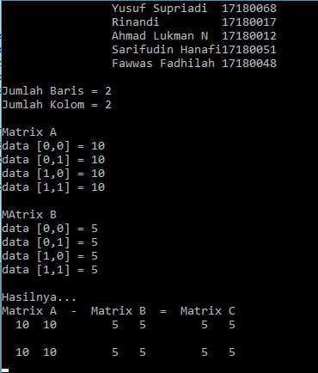

**Coding :**

#include <iostream.h>

#include <conio.h>

#include <iomanip.h>

int i,j, baris, kolom, m1[2][2], m2[2][2], hasil[2][2];

main()

{

clrscr();

cout<<"\t\tYusuf Supriadi\t17180068\n";

cout<<"\t\tRinandi\t\t17180017\n";

cout<<"\t\tAhmad Lukman N\t17180012\n";

cout<<"\t\tSarifudin Hanafi17180051\n";

cout<<"\t\tFawwas Fadhilah\t17180048\n\n";

do

{

cout<<"Jumlah Baris = ";cin>>baris;

cout<<"Jumlah Kolom = ";cin>>kolom;

}

while((baris>2)||(kolom>2));

cout<<"\nMatrix A\n";

for(i=0;i<baris;i++)

for(j=0;j<kolom;j++)

{

cout<<"data ["<<i<<","<<j<<"] = ";

cin>>m1[i][j];

}

cout<<"\nMAtrix B\n";

for(i=0;i<baris;i++)

for(j=0;j<kolom;j++)

{

cout <<"data [" << i << "," << j << "] = ";

cin>>m2[i][j];

}

for(i=0; i<baris;i++)

for(j=0; j<kolom; j++)

hasil[i][j] = m1[i][j] - m2[i][j];

cout << "\nHasilnya...\n";

cout << "Matrix A - Matrix B = Matrix C";

for(i=0; i< baris; i++)

{

cout<<'\n';

for(j=0; j<kolom; j++)

cout << setw(4) << m1[i][j];

cout << " ";

for(j=0; j<kolom; j++)

cout << setw(4) << m2[i][j];

cout << " ";

for(j=0; j<kolom; j++)

cout << setw(4) << hasil[i][j];

cout << endl;

}

getch();

}

1. Perkalian dua buah matrix

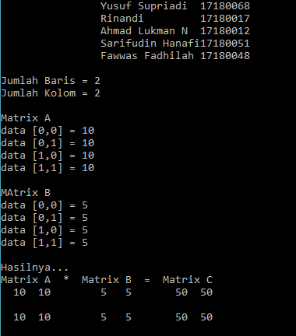

**Coding :**

#include <iostream.h>

#include <conio.h>

#include <iomanip.h>

int i,j, baris, kolom, m1[2][2], m2[2][2], hasil[2][2];

main()

{

clrscr();

cout<<"\t\tYusuf Supriadi\t17180068\n";

cout<<"\t\tRinandi\t\t17180017\n";

cout<<"\t\tAhmad Lukman N\t17180012\n";

cout<<"\t\tSarifudin Hanafi17180051\n";

cout<<"\t\tFawwas Fadhilah\t17180048\n\n";

do

{

cout<<"Jumlah Baris = ";cin>>baris;

cout<<"Jumlah Kolom = ";cin>>kolom;

}

while((baris>2)||(kolom>2));

cout<<"\nMatrix A\n";

for(i=0;i<baris;i++)

for(j=0;j<kolom;j++)

{

cout<<"data ["<<i<<","<<j<<"] = ";

cin>>m1[i][j];

}

cout<<"\nMAtrix B\n";

for(i=0;i<baris;i++)

for(j=0;j<kolom;j++)

{

cout <<"data [" << i << "," << j << "] = ";

cin>>m2[i][j];

}

for(i=0; i<baris;i++)

for(j=0; j<kolom; j++)

hasil[i][j] = m1[i][j] * m2[i][j];

cout << "\nHasilnya...\n";

cout << "Matrix A * Matrix B = Matrix C";

for(i=0; i< baris; i++)

{

cout<<'\n';

for(j=0; j<kolom; j++)

cout << setw(4) << m1[i][j];

cout << " ";

for(j=0; j<kolom; j++)

cout << setw(4) << m2[i][j];

cout << " ";

for(j=0; j<kolom; j++)

cout << setw(4) << hasil[i][j];

cout << endl;

}

getch();

}